Name: Arun Sharma

Date: 06/23/2024

Assignment: [Assignment: Assignment: MySQL Functions Module 5.2 Assignment of (Module 5: SQL Functions ERD Construction)

1. Section for CURRENT_DATE():

Explanation: The CURRENT_DATE() function is a MySQL function that retrieves the current date in the format YYYY-MM-DD. This function is useful when you need to record or display the current date. It can be used in various scenarios, such as generating reports, logging the date of transactions, or displaying the current date on a user interface.

= SQL Statement:

SELECT CURRENT_DATE();

= Screenshot :

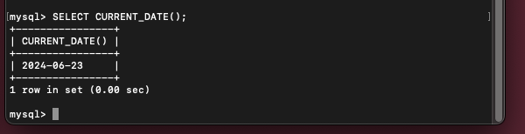

2. Section for CURRENT_DATE() AS 'Today\'s Date':

Explanation: Using CURRENT_DATE() by itself returns the current date with the column header CURRENT_DATE(), which might not be very user-friendly. By using an alias, you can rename the column header to something more descriptive. In this case, CURRENT_DATE() AS 'Today\'s Date' renames the column header to Today's Date. The alias makes the output easier to understand, especially when presenting data to end-users or in reports.

= SQL Statement:

SELECT CURRENT_DATE() AS 'Today\'s Date';

= Screenshot :

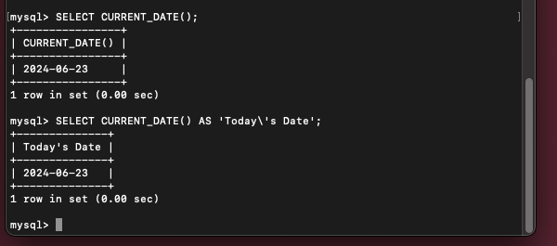

* Experiment with Three MySQL Functions from W3Schools:

(All three output in one screenshot)

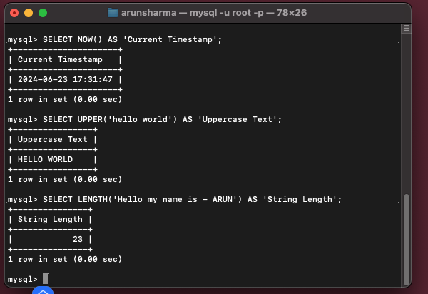

1. Section for NOW():

Explanation: The NOW() function retrieves the current date and time in the format YYYY-MM-DD HH:MM:SS. This function is useful for logging timestamps of transactions or events, creating records of when certain actions occurred, and tracking changes in a database. For instance, it can be used in an e-commerce application to record the exact time a purchase was made or when a user logs in.

= SQL Statement:

SELECT NOW() AS 'Current_Timestamp';

2. Section for UPPER():

Explanation: The UPPER() function converts all characters in a string to uppercase. This function is useful for standardizing text data, such as user inputs, ensuring consistency in data storage, and simplifying text comparisons. For example, it can be used to convert all user-entered email addresses to uppercase before storing them in a database, ensuring that comparisons are case-insensitive.

= SQL Statement:

SELECT UPPER('hello world') AS 'Uppercase_Text';

3. Section for LENGTH():

Explanation: The LENGTH() function returns the length of a string in bytes. This function is useful for validating the length of user inputs or data fields, ensuring that data meets specified length requirements, and performing data quality checks. For example, it can be used to verify that a user's password meets minimum length requirements or to check the length of a product description before storing it in a database.

= SQL Statement:

SELECT LENGTH('OpenAI GPT-4') AS 'String_Length';